**Report z cvičenia č.10**

**Pavol Trník, Rastislav Kupčík**

**Topológia:**

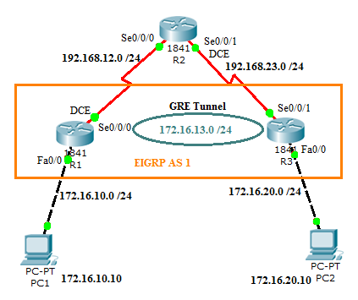

**Toky:**

Generovali sme 3 rôzne toky – Voice, Gaming a Data, pričom v každej úlohe sme vykonali tri rôzne scenáre, kedy bola intenzita súčtového toku 75%, 100% a 125% z prenosovej kapacity linky.

*75%:*

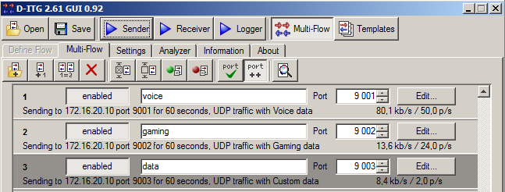

*100%:*

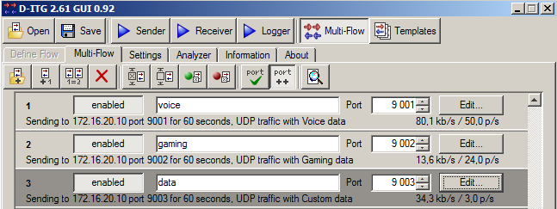

*125%:*

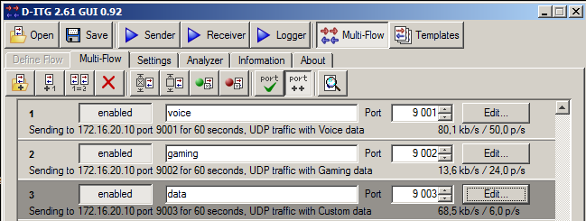

**Základná konfigurácia:**

V prvom kroku bolo potrebné nakonfigurovať WFQ na smerovači R1.

policy-map WFQ

class class-default

fair-queue

in s0/0/0

service-policy output WFQ

Následne sme nakonfigurovali podľa zadania značkovanie paketov na smerovači R1 (sender) a aplikovali sme ho na vnútorné rozhranie Fa0/0. Detailnú konfiguráciu neuvádzame, keďže s nastavovaním značkovania na smerovači sa zaoberáme takmer každé cvičenie, a bolo detailne popísané v predošlých reportoch.

Následne sme nakonfigurovali default route:

R1(config)# ip route 0.0.0.0 0.0.0.0 192.168.12.2

R3(config)# ip route 0.0.0.0 0.0.0.0 192.168.23.2

V ďalšom kroku bolo potrebné vytvoriť tunel medzi R1 a R3:

R1(config)# interface tunnel 0

R1(config-if)# tunnel source serial 0/0/0

R1(config-if)# tunnel destination 192.168.23.3

R1(config-if)# ip address 172.16.13.1 255.255.255.0

R3(config)# interface tunnel 0

R3(config-if)# tunnel source fa 0/1

R3(config-if)# tunnel destination 192.168.12.1

R3(config-if)# ip address 172.16.13.3 255.255.255.0

Statické smerovanie do LAN za R1 a R3 cez vytvorený tunel:

R1(config)# ip route 172.16.20.0.255.255.255.0 tunnel 0

R3(config)# ip route 172.16.10.0.255.255.255.0 tunnel 0

Po zadaní týchto príkazov bola zabezpečená plná konektivita do celej siete.

**Scenár bez QoS pre-classify:**

**So značkovaním:**

a.

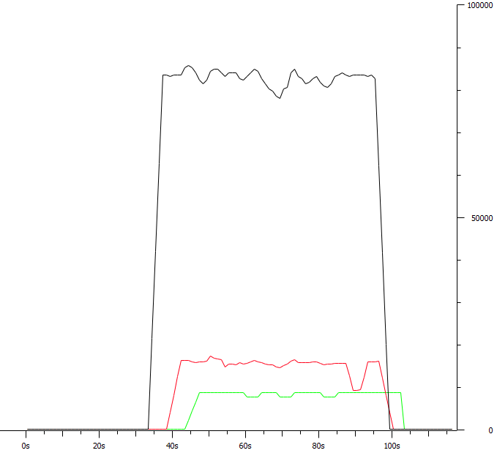

*75%*

__________________________________________________________

**************** TOTAL RESULTS ******************

__________________________________________________________

Number of flows = 3

Total time = 62.587000 s

Total packets = 4400

Minimum delay = 284.539000 s

Maximum delay = 291.744000 s

Average delay = 289.797147 s

Average jitter = 0.040369 s

Delay standard deviation = 1.494578 s

Bytes received = 621889

Average bitrate = 79.491140 Kbit/s

Average packet rate = 70.302139 pkt/s

Packets dropped = 0 (0.00 %)

Average loss-burst size = 0 pkt

Error lines = 0

----------------------------------------------------------

b.

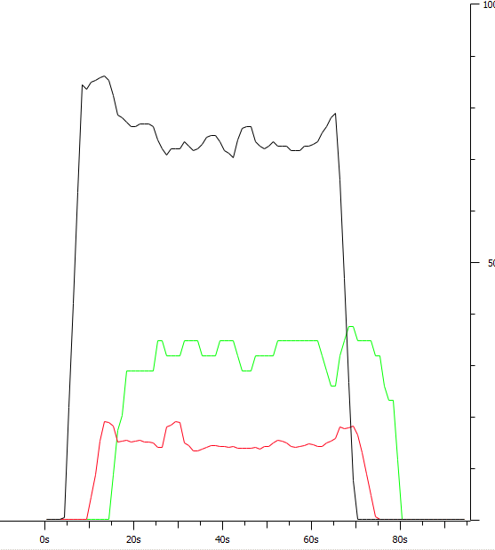

*100%*

__________________________________________________________

**************** TOTAL RESULTS ******************

__________________________________________________________

Number of flows = 3

Total time = 71.084000 s

Total packets = 4252

Minimum delay = -76.333000 s

Maximum delay = -69.549000 s

Average delay = -71.423320 s

Average jitter = 0.048888 s

Delay standard deviation = 1.536602 s

Bytes received = 766869

Average bitrate = 86.305667 Kbit/s

Average packet rate = 59.816555 pkt/s

Packets dropped = 2692 (38.77 %)

Average loss-burst size = 10.393822 pkt

Error lines = 0

----------------------------------------------------------

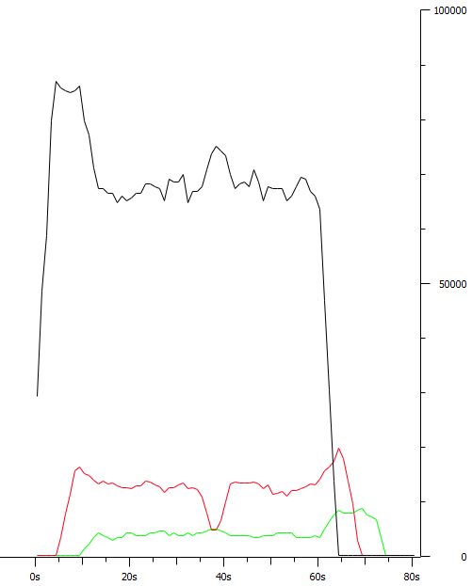c.

*125%*

__________________________________________________________

**************** TOTAL RESULTS ******************

__________________________________________________________

Number of flows = 3

Total time = 70.062000 s

Total packets = 3812

Minimum delay = -253.399000 s

Maximum delay = -247.557000 s

Average delay = -248.967859 s

Average jitter = 0.054327 s

Delay standard deviation = 1.515525 s

Bytes received = 754538

Average bitrate = 86.156604 Kbit/s

Average packet rate = 54.408952 pkt/s

Packets dropped = 883 (18.81 %)

Average loss-burst size = 2.077647 pkt

Error lines = 0

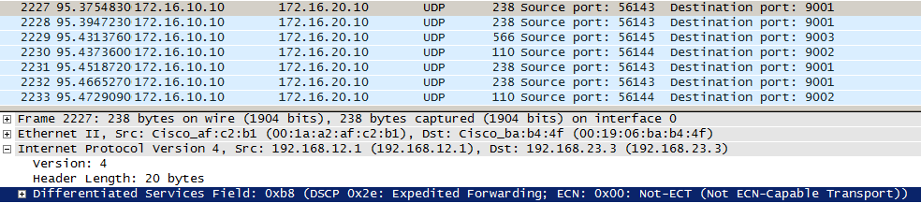

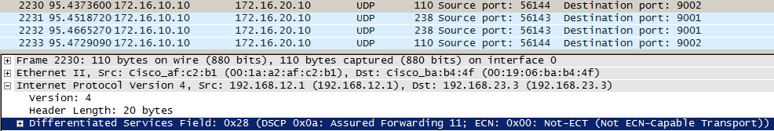

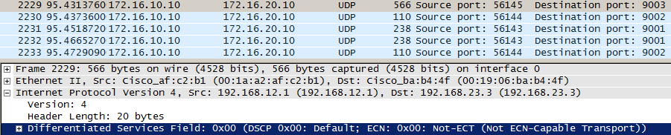

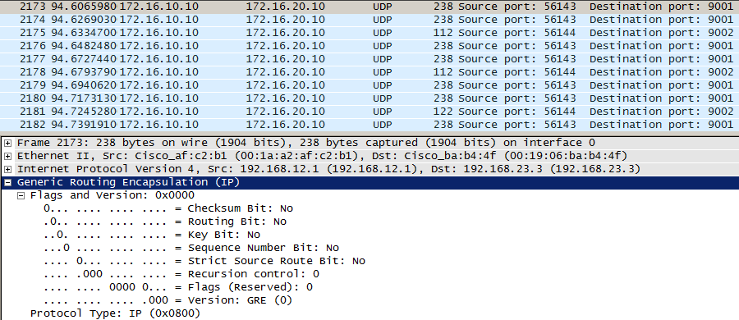

**Bez značkovania:**

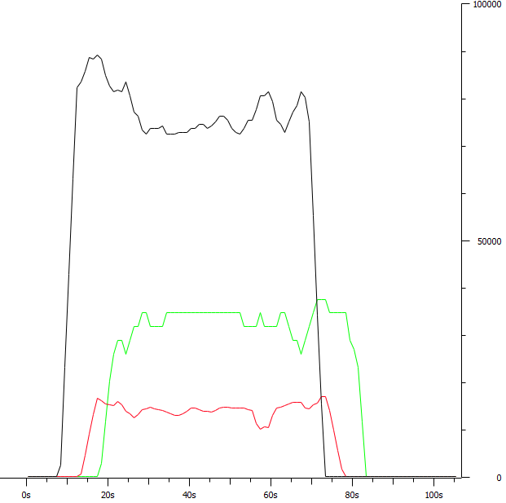b.

*100%*

__________________________________________________________

**************** TOTAL RESULTS ******************

__________________________________________________________

Number of flows = 3

Total time = 70.235000 s

Total packets = 4207

Minimum delay = -264.935000 s

Maximum delay = -263.091000 s

Average delay = -263.697360 s

Average jitter = 0.016396 s

Delay standard deviation = 0.335792 s

Bytes received = 773655

Average bitrate = 88.121877 Kbit/s

Average packet rate = 59.898911 pkt/s

Packets dropped = 377 (8.22 %)

Average loss-burst size = 1.597458 pkt

Error lines = 0

----------------------------------------------------------

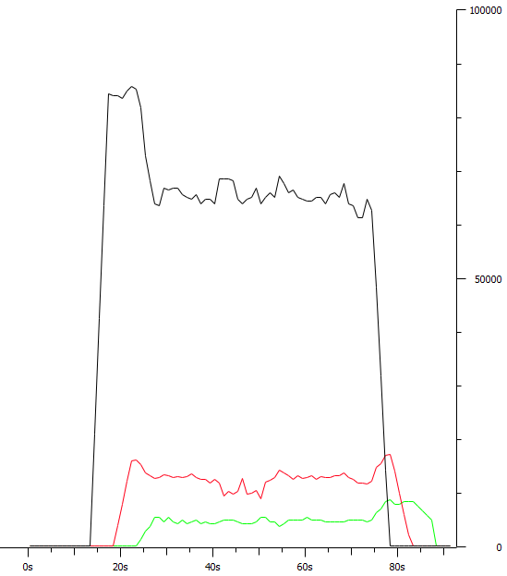c.

*125%*

__________________________________________________________

**************** TOTAL RESULTS ******************

__________________________________________________________

Number of flows = 3

Total time = 70.437000 s

Total packets = 3765

Minimum delay = -264.480000 s

Maximum delay = -263.315000 s

Average delay = -263.803329 s

Average jitter = 0.022545 s

Delay standard deviation = 0.255299 s

Bytes received = 787607

Average bitrate = 89.453781 Kbit/s

Average packet rate = 53.452021 pkt/s

Packets dropped = 939 (19.96 %)

Average loss-burst size = 2.129252 pkt

Error lines = 0

----------------------------------------------------------

**Scenár s QoS pre-classify:**

Na smerovačoch R1 a R3 sme nakonfigurovali QoS pre-classify a zrušili sme značkovanie na vstupnom rozhraní R1:

R1(config)# interface tunnel 0

R1(config-if)# qos pre-classify

R3(config)# interface tunnel 0

R3(config-if)# qos pre-classify

R1(config)# interface fa0/0

R1(config-if)# no service-policy input ZNACKOVANIE

a.

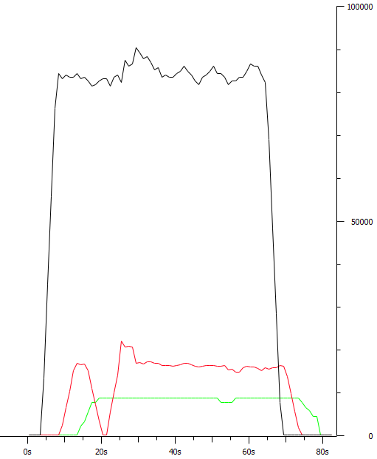

*75%*

__________________________________________________________

**************** TOTAL RESULTS ******************

__________________________________________________________

Number of flows = 3

Total time = 70.580000 s

Total packets = 4470

Minimum delay = 11.175000 s

Maximum delay = 17.443000 s

Average delay = 15.996000 s

Average jitter = 0.040420 s

Delay standard deviation = 1.394697 s

Bytes received = 634895

Average bitrate = 71.963162 Kbit/s

Average packet rate = 63.332389 pkt/s

Packets dropped = 61 (1.35 %)

Average loss-burst size = 30.500000 pkt

Error lines = 0

----------------------------------------------------------

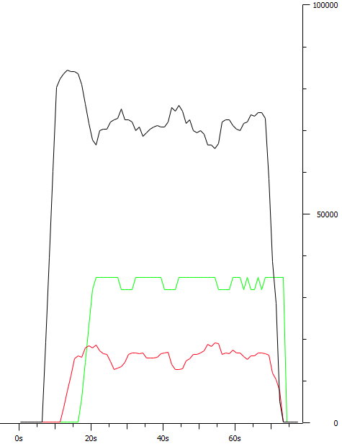b.

*100%*

__________________________________________________________

**************** TOTAL RESULTS ******************

__________________________________________________________

Number of flows = 3

Total time = 63.708000 s

Total packets = 4136

Minimum delay = 11.921000 s

Maximum delay = 19.468000 s

Average delay = 17.210229 s

Average jitter = 0.069938 s

Delay standard deviation = 1.793478 s

Bytes received = 731130

Average bitrate = 91.810134 Kbit/s

Average packet rate = 64.921203 pkt/s

Packets dropped = 437 (9.56 %)

Average loss-burst size = 2.185000 pkt

Error lines = 0

----------------------------------------------------------

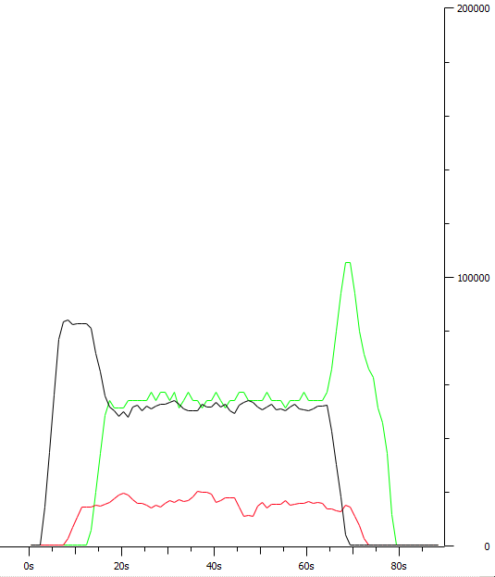c.

*125%*

__________________________________________________________

**************** TOTAL RESULTS ******************

__________________________________________________________

Number of flows = 3

Total time = 71.708000 s

Total packets = 3766

Minimum delay = 12.987000 s

Maximum delay = 20.191000 s

Average delay = 17.855942 s

Average jitter = 0.084446 s

Delay standard deviation = 1.627665 s

Bytes received = 852927

Average bitrate = 95.155575 Kbit/s

Average packet rate = 52.518547 pkt/s

Packets dropped = 987 (20.77 %)

Average loss-burst size = 2.583770 pkt

Error lines = 0

----------------------------------------------------------

**Porovnanie:**

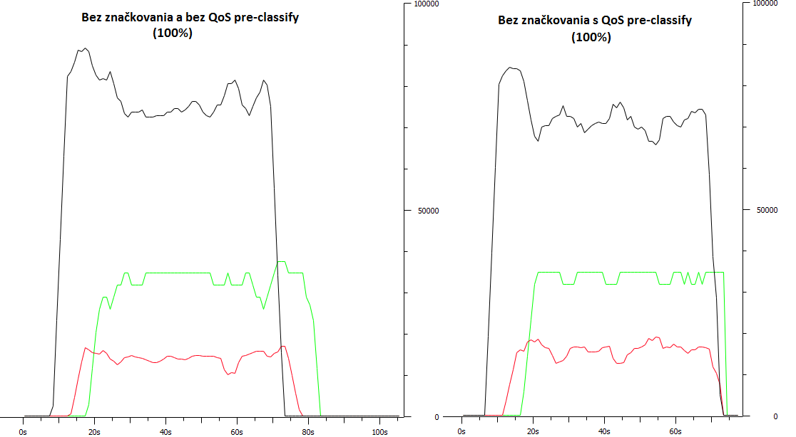

Average jitter: 0,0164 s Average jitter: 0,0699 s

Packets dropped: 377 (8,72%) Packets dropped: 437 (9,56%)

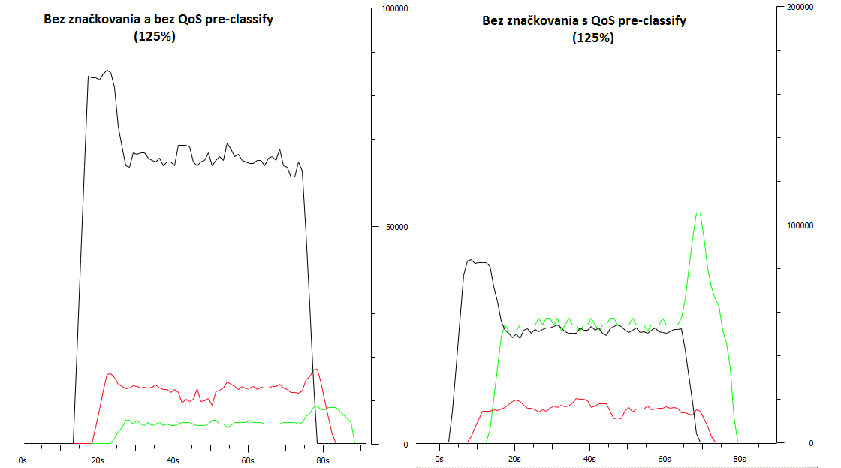

Average jitter: 0,0225 s Average jitter: 0,0844 s

Packets dropped: 939 (19,96%) Packets dropped: 987 (20,77%)